DISHES AND THEIR ALLERGEN CONTENT week 3

 | DISHES | 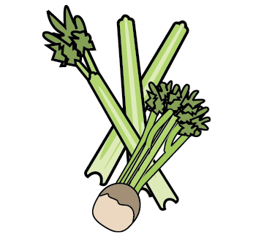 | 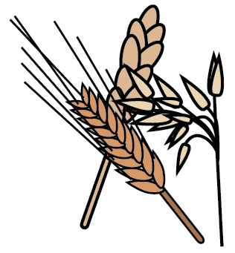 | 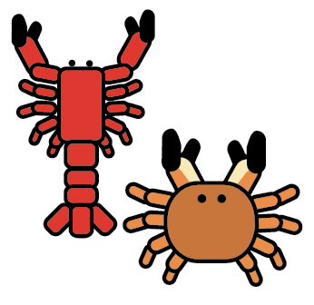 | 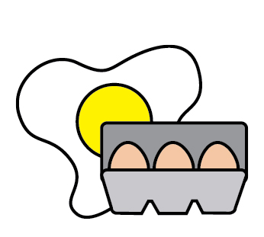 | 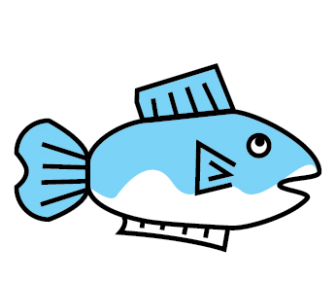 | 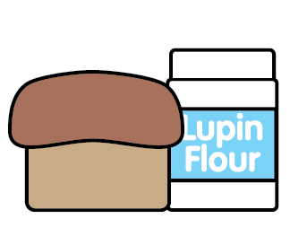 | 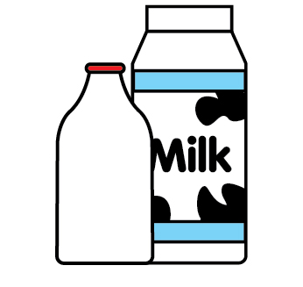 | 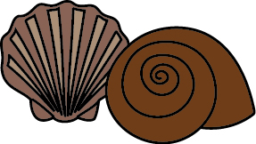 | 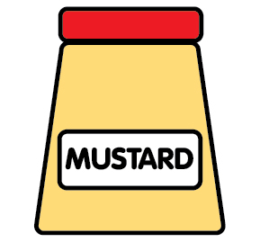 | 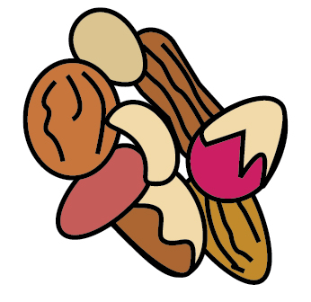 | 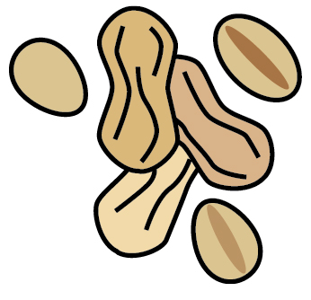 | 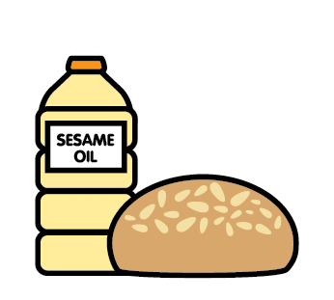 |  | 
 |  | Celery | Cereal’s gluten | Crustaceans | Eggs | Fish | Lupin | Milk | Mollusc | Mustard | Nuts | Peanuts | Sesame seeds | Soya | Sulphur Dioxide
 | MONDAY
 | Crumpets |  | Wheat |  |  |  |  | May |  |  |  |  |  | May
 | Dietary crumpets |  |  |  | X
 | Spaghetti Bolognese |  | Wheat |  |  |  |  |  |  |  |  |  |  |  | Sulphites
 | Lentil Bolognese |  | Gluten |  |  |  |  |  |  |  |  |  |  | May | Sulphites
 | Pasta |  | Gluten
 | Peaches
 | Ice-cream |  |  |  |  |  |  | X |  |  |  |  |  |  | Sulphites
 | Dairy free ice-cream |  |  |  |  |  |  |  |  |  |  |  |  | May
 | Wholemeal bread |  | Wheat oats rye barley |  |  |  |  |  |  |  |  |  |  | May
 | Dietary bread
 | Salmon |  |  |  |  | X
 | Tuno
 | TUESDAY
 | Toast |  | Wheat oat rye barley |  |  |  |  |  |  |  |  |  |  | May
 | Dietary toast |  |  |  | X
 | Basil chilli chicken |  |  |  |  |  |  |  |  |  |  |  |  |  | Sulphites
 | Basil chilli mixed bean |  |  |  |  |  |  |  |  |  |  |  |  | May | Sulphites
 | Strawberry compote |  |  |  |  |  |  | X
 | Dairy free compote |  | Oats
 | Cheese |  |  |  |  |  |  | X
 | Free from cheese |  | Oats
 | Wraps |  | Barley Wheat oats rye
 | Dietary wraps
 | WEDNESDAY
 | Crumpets |  | Wheat |  |  |  |  | May |  |  |  |  |  | May
 | Dietary loaf
 | Roast pork
 | Yoghurt |  |  |  |  |  |  | X
 | Dietary yoghurt |  | Oats
 | Hummus |  | Gluten |  |  |  |  |  |  |  |  |  |  |  | May
 | Pitta bread |  | Wheat oat rye barley |  |  |  |  | May |  |  |  |  |  | X | May
 | Cream cheese |  |  |  | X
 | Dietary bread |  |  |  | X
 | THURSDAY
 | Toast |  | Wheat oat rye barley |  |  |  |  |  |  |  |  |  |  | May
 | Dietary bread |  |  |  | X
 | Tomato pasta |  | Wheat |  |  |  |  |  |  |  |  |  |  |  | May
 | Chickpea pasta |  | Wheat |  |  |  |  |  |  |  |  |  |  |  | May
 | Dietary bread
 | Cream cheese |  |  |  |  |  |  | X
 | Whole-wheat bread |  | Wheat oat barley rye |  |  |  |  |  |  |  |  |  |  | May
 | FRIDAY
 | Toast |  | Wheat oat rye barley |  |  |  |  |  |  |  |  |  |  | May
 | Dietary bread |  |  |  | X
 | Jacket potatoes
 | Baked beans
 | Cheese
 | Rice pudding |  |  |  |  |  |  | X
 | Dairy free cheese |  | Oats |  |  |  |  | X
 | Dairy free rice pudding |  | Oats
 | Pancakes |  | Wheat rye |  | May |  |  | May |  |  |  |  |  | May
 | Dietary pancakes |  |  |  | X

