DISHES AND THEIR ALLERGEN CONTENT week 4

 | DISHES | 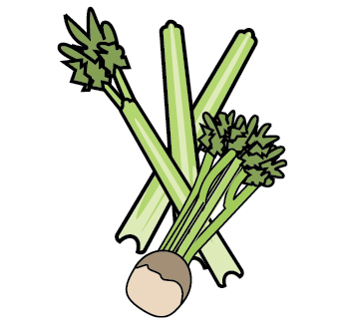 | 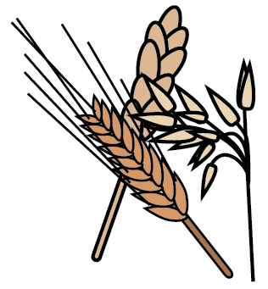 | 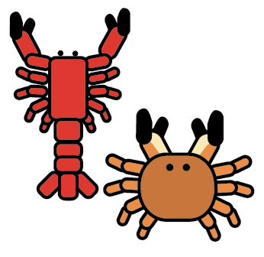 | 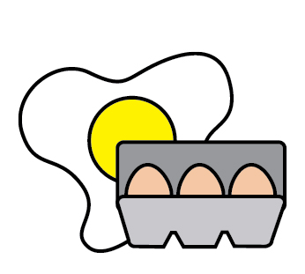 | 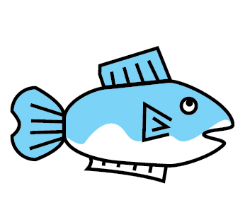 | 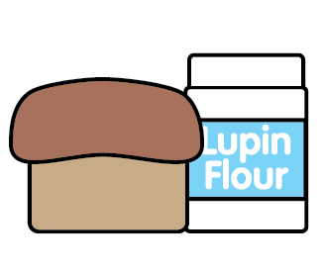 | 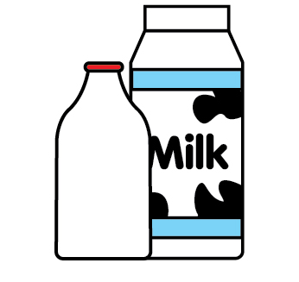 | 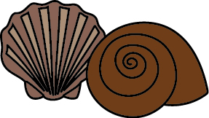 | 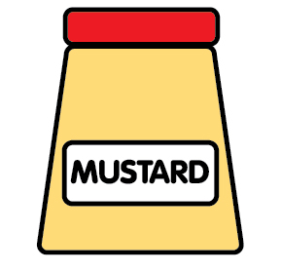 | 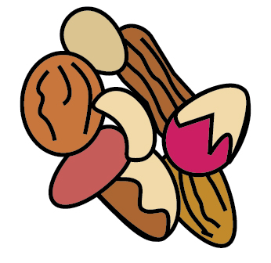 | 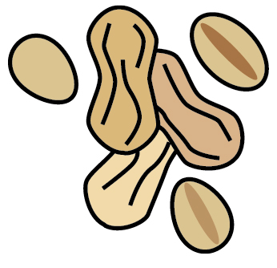 | 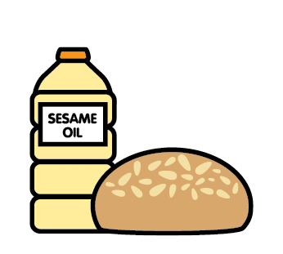 | 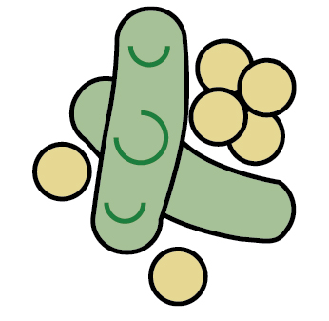 | 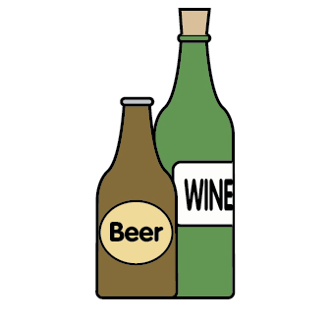
 |  | Celery | Cereals gluten | Crustaceans | Eggs | Fish | Lupin | Milk | Mollusc | Mustard | Nuts | Peanuts | Sesame seeds | Soya | Sulphur Dioxide
 | MONDAY
 | Crumpets |  | Wheat |  |  |  |  | May |  |  |  |  |  | May
 | Dietary crumpet |  |  |  | X
 | Tuna pasta bake |  | Wheat |  |  | X |  | X |  |  |  |  |  |  | May
 | Tuno pasta bake |  | Wheat |  |  |  |  | X |  |  |  |  |  | May | May
 | Dairy gluten soya free pasta |  |  | c
 | Frozen yoghurt |  |  |  |  |  |  | X
 | Free from ice-cream |  |  |  |  |  |  |  |  |  |  |  |  | May
 | Dairy free cheese |  | Oats
 | Cheese |  |  |  |  |  |  | X
 | Pitta bread |  | Oat wheat barley |  |  |  |  | May
 | TUESDAY
 | Toast |  | Wheat oat rye barley |  |  |  |  |  |  |  |  |  |  | May
 | Dietary toast |  |  |  | X
 | Chicken tikka mushroom |  | May |  |  |  |  |  |  |  |  |  |  |  | May
 | Green lentil, tikka mushroom |  | Wheat |  |  |  |  |  |  |  |  |  |  | X | May
 | Semolina |  | Gluten
 | Free from semolina |  |  |  |  |  |  | X
 | Fruited loaf |  | Barley oats rye |  | X |  |  | X |  |  |  |  |  | May
 | Dairy free fruit loaf |  | Barley wheat |  |  |  |  |  |  |  |  |  |  | May
 | Dietary bread |  |  |  | X
 | WEDNESDAY
 | Crumpets |  | Wheat oat barley rye |  |  |  |  | May |  |  |  |  |  | May
 | Dietary bread |  |  |  | X
 | Ham bow pasta |  | Wheat |  |  |  |  |  |  |  |  |  |  |  | May
 | Gluten free pasta
 | Chickpea pasta salad |  |  |  |  |  |  |  |  |  |  |  |  |  | May
 | Bread |  | Wheat rye oat barley |  |  |  |  |  |  |  |  |  |  | X
 | Chicken mayonnaise \ |  |  |  |  |  |  |  |  | X
 | Hummus |  | Gluten |  |  |  |  |  |  | X |  |  |  |  | May
 | Dietary bread |  |  |  | X
 | THURSDAY
 | Toast |  | Wheat oat rye barley |  |  |  |  |  |  |  |  |  |  | X
 | Dietary toast
 | Lamb red lentil with sweet potato |  | Gluten |  |  |  |  |  |  |  |  |  |  |  | May
 | Braised red lentil |  | Gluten |  |  |  |  |  |  |  |  |  |  |  | May
 | Pilchard pate |  |  |  |  | X
 | Soft cheese |  |  |  |  |  |  | X
 | Crusty bread |  | Wheat oat rye barley |  |  |  |  | May |  |  |  |  |  | X
 | Dietary bread |  |  |  | X
 | FRIDAY
 | Toast |  | Wheat rye barley |  |  |  |  |  |  |  |  |  |  | May
 | Dietary bread
 | Chicken and leek potato | May |  |  |  |  |  |  |  |  |  |  |  |  | May
 | Pinto bean leek and potato | May | May |  |  |  |  |  |  |  |  |  |  | May | May
 | Crusty bread |  | Wheat rye barley |  |  |  |  | May
 | Dietary bread |  |  |  | X
 | Pancakes |  | Wheat |  | X |  |  | X |  |  |  |  |  | May
 | Free from pancakes |  |  |  | May
 | Baby crackers |  | Wheat rye oats |  |  |  |  | May

