DISHES AND THEIR ALLERGEN CONTENT week 2

 | DISHES | 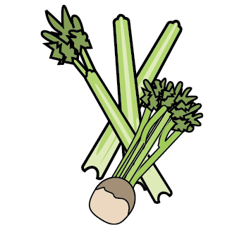 | 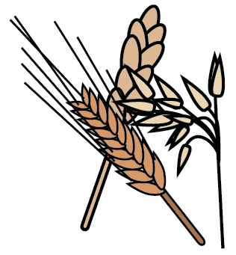 | 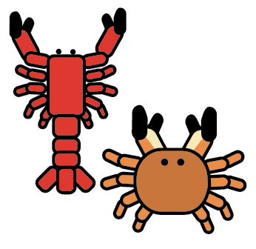 | 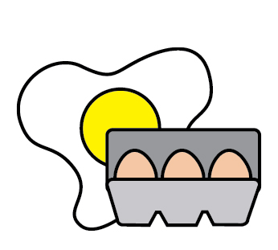 |  | 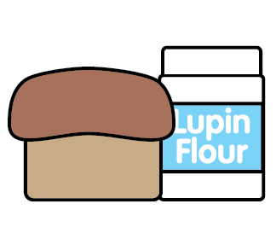 |  | 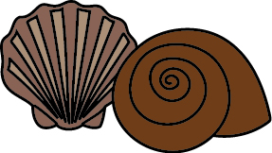 | 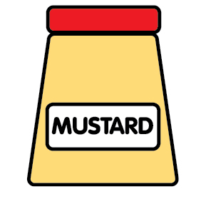 | 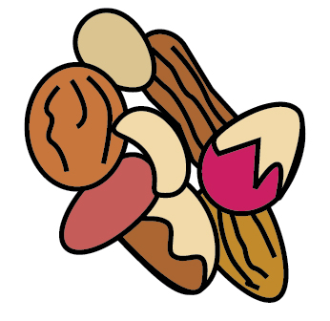 | 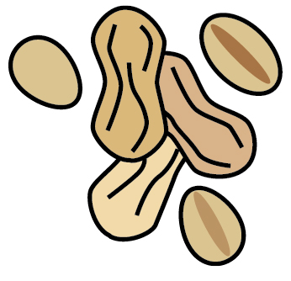 | 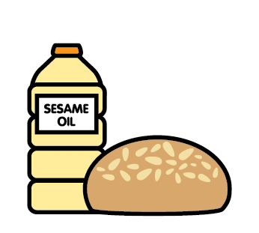 |  | 
 |  | Celery | Cereals gluten | Crustaceans | Eggs | Fish | Lupin | Milk | Mollusc | Mustard | Nuts | Peanuts | Sesame seeds | Soya | Sulphur Dioxide
 | MONDAY
 | Crumpets |  | Wheat |  |  |  |  | may |  |  |  |  |  | may
 | Dietary toast
 | Mixed bean chilli beef |  |  |  |  |  |  |  |  |  |  |  |  |  | Sulphites
 | Mixed bean chilli |  |  |  |  |  |  |  |  |  |  |  |  |  | Sulphites
 | Couscous |  | May barley spelt
 | Banana yoghurt |  |  |  |  |  |  | x
 | Dietary yoghurt |  |  |  |  |  |  |  |  |  |  |  |  | X
 | Fruit blend
 | Tuna mayonnaise |  |  |  | x | x |  |  |  | x
 | Tuno mayonnaise |  |  |  | x | x |  |  |  | x
 | Pitta bread |  | Rye oat barley spelt |  |  |  |  | May
 | Dietary pitta
 | TUESDAY
 | Toast |  | Wheat oats rye |  |  |  |  |  |  |  |  |  |  | X
 | Dietary toast
 | Sweet and sour chicken |  | Barley |  |  |  |  |  |  |  |  |  |  |  | Sulphites
 | Sweet and sour chickpeas |  | Barley |  |  |  |  |  |  |  |  |  |  |  | Sulphites
 | Pasta |  | Wheat
 | Fresh fruit
 | Cheese and tomato pizza |  | Wheat |  | x |  |  | x
 | Free from cheese pizza |  | Oats
 | WEDNESDAY
 | Crumpets |  | Wheat |  |  |  |  | x |  |  |  |  |  | x
 | Dietary toast
 | Tarragon beef and onion |  |  |  |  |  |  |  |  |  |  |  |  |  | Sulphites
 | Tarragon green lentils |  |  |  |  |  |  |  |  |  |  |  |  |  | Sulphites
 | Sugar free jelly |  |  |  |  |  |  | x
 | Vegan jelly
 |  |  |  |  | x | x
 | Coronation chicken |  |  |  | x |  |  |  |  | x
 | Coronation chickpea |  |  |  | x |  |  |  |  | x
 | Naan bread |  | wheat
 | Dietary bread
 | THURSDAY
 | Toast |  | barley oat rye
 | Dietary toast
 | Lamb tagine |  | gluten |  |  |  |  |  |  |  |  |  |  |  | Sulphites
 | Chickpea quinoa tagine |  | Wheat barley spelt |  |  |  |  |  |  |  |  |  |  | May | Sulphites
 | Sugar free semolina |  | Wheat |  |  |  |  | x
 | Dairy free semolina |  | Oats
 | Egg and cress |  |  |  | x
 | Soft cheese |  |  |  |  |  |  | x
 | Wholemeal bread |  | Wheat oats rye |  |  |  |  |  |  |  |  |  |  | x
 | Dietary bread
 | FRIDAY
 | Pancakes |  | Wheat |  | X |  |  | x
 | Dietary pancakes |  |  |  | X
 | Crème fraiche chicken |  |  |  |  |  |  |  |  | x |  |  |  |  | Sulphites
 | Free from crème fraiche lentils |  | May oats |  |  |  |  |  |  |  |  |  |  |  | Sulphites
 | Fresh fruit salad
 | Cheese & onion spread |  |  |  |  |  |  | x |  | x
 | Free from cheese |  | Oats
 | Egg free mayonnaise |  |  |  |  |  |  |  |  | x |  |  |  | may
 | Crackers |  | Wheat

