DISHES AND THEIR ALLERGEN CONTENT week 1

 | DISHES | 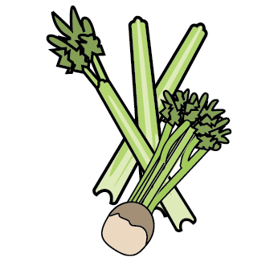 | 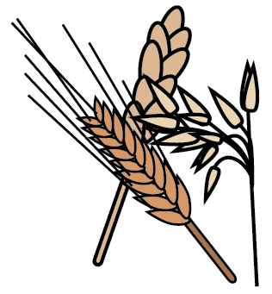 | 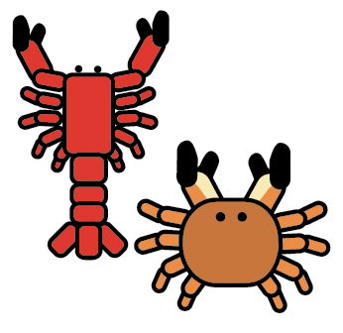 |  |  | 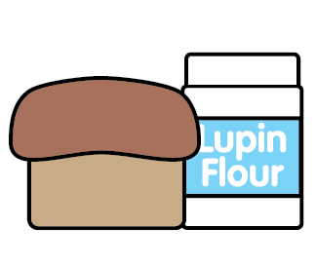 |  | 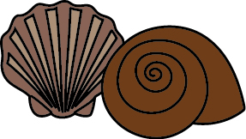 | 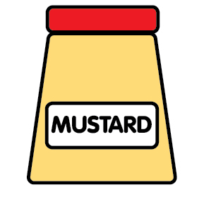 | 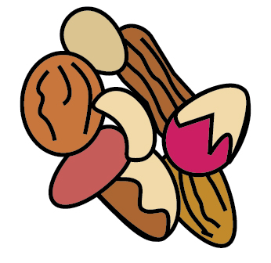 | 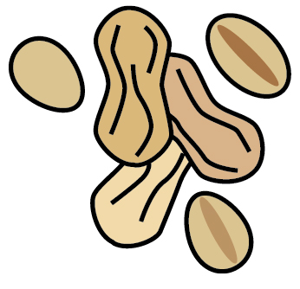 | 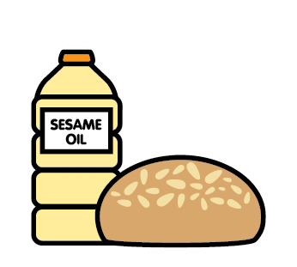 |  | 
 |  | Celery | Cereals | Crustaceans | Eggs | Fish | Lupin | Milk | Mollusc | Mustard | Nuts | Peanuts | Sesame seeds | Soya | Sulphur Dioxide
 | MONDAY
 | Crumpet |  | Wheat |  |  |  |  | May |  |  |  |  |  | May
 | Dietary crumpet |  |  |  | X
 | Braised lamb and rosemary |  |  |  |  |  |  |  |  |  |  |  |  | May | May
 | Red lentil and rosemary |  |  |  |  |  |  |  |  |  |  |  |  | May | May
 | Fresh fruit bowl
 | Cream cheese |  |  |  |  |  |  | X
 | Wholemeal bread |  | Wheat oat barley rye
 | Gluten/soya dairy free bread |  |  |  | May
 | TUESDAY
 | Toast |  | Wheat oat rye barley |  |  |  |  |  |  |  |  |  |  | May
 | Dietary bread |  |  |  | X
 | Curried chicken mushroom |  |  |  |  |  |  |  |  |  |  |  |  |  | May
 | Curried chickpea mushroom |  |  |  |  |  |  |  |  |  |  |  |  |  | May
 | Greek yoghurt |  |  |  |  |  |  | X
 | Dairy free yoghurt |  |  |  |  |  |  |  |  |  |  |  |  | May
 | Fruit blend
 | Salmon |  |  |  |  | X
 | Wholemeal bread |  | Wheat oat rye barley |  |  |  |  |  |  |  |  |  |  | X
 | Dietary bread |  |  |  | X
 | WEDNESDAY
 | Crumpets |  | Wheat |  | X |  |  | May
 | Dietary loaf |  |  |  | X
 | Lasagne |  | Wheat |  | X |  |  | X |  |  |  |  |  |  | May
 | Dairy free lasagne |  | Oats |  |  |  |  |  |  |  |  |  |  |  | May
 | Veggie lasagne |  | Wheat |  | X |  |  | x |  |  |  |  |  |  | May
 | Blended pears
 | Cheese and egg blend |  |  |  | X |  |  | X
 | Dairy free cheese |  | Oats
 | Bread |  | Wheat oat rye barley |  | X |  |  |  |  |  |  |  |  | May
 | Dietary bread
TH

 | THURSDAY
 | Toast |  | Wheat oat barley rye |  |  |  |  |  |  |  |  |  |  | May
 | Dietary toast |  |  |  | X
 | Chicken roast
 | Quorn fillets |  |  |  | X
 | Mashed potato |  |  |  |  |  |  | X
 | Dairy free mash |  | Oats
 | Dietary yoghurt |  | Oats |  |  |  |  |  |  |  |  |  |  | May
 | Fruited yoghurt
 | Pitta bread |  | Wheat oat barley rye |  |  |  |  | May |  |  |  |  |  | May
 | Hummus |  | Gluten |  |  |  |  |  |  |  |  |  |  |  | May
 | FRIDAY
 | Pancakes |  | Wheat rye |  | May |  |  | May |  |  |  |  |  | May
 | Dietary pancakes |  |  |  | X
 | Beef cottage pie |  |  |  |  |  |  | X |  |  |  |  |  | May | May
 | quinoa cottage pie |  | Barley spelt wheat |  |  |  |  | X |  |  |  |  |  | May | May
 | Diary free cottage pie |  | Oats |  |  |  |  |  |  |  |  |  |  |  | May
 | Rice pudding |  |  |  |  |  |  | x
 | Dairy free rice pudding |  | Oats
 | Croissants |  | Gluten |  | X |  |  | X
 | Gluten free pancakes |  |  |  | X

